*CORU_Reg_logo.pdf****Carolyn* *Webb***

***Senior Speech and Language Therapist***

*‘The Speech Grove’*

*Tel: 089 4034184*

*Email: thespeechgrove@gmail.**com*  **CORU Registration Number SL 015115**

**The Speech Grove**

**Consent Form**

*Print* *full name(s) of parent(s)/guardian(s)*

I consent that

*(full name)*

either I attend or my child attend for speech and

language therapy with Carolyn Webb, CORU registered Speech and Language Therapist.

I have read about The Speech Grove’s Service Overview with a link listed here: <https://thespeechgrove.com/about-you/> and my signing here indicates my acceptance of its terms and conditions.

I have read the Speech Grove Privacy Policy:

<https://thespeechgrove.com/the-speech-grove-privacy-policy/>

and by signing below I consent to personal data relating to my child to be managed in accordance with the manner listed therein, and in accordance with GDPR guidelines.

I have read the Informed Teletherapy Consent form:

<https://thespeechgrove.com/informed-consent/>

and my signing below indicates agreement with its terms and conditions.

Signed *(parent/guardian)* Today’s date:

Signed *(parent/guardian)* Today’s date:

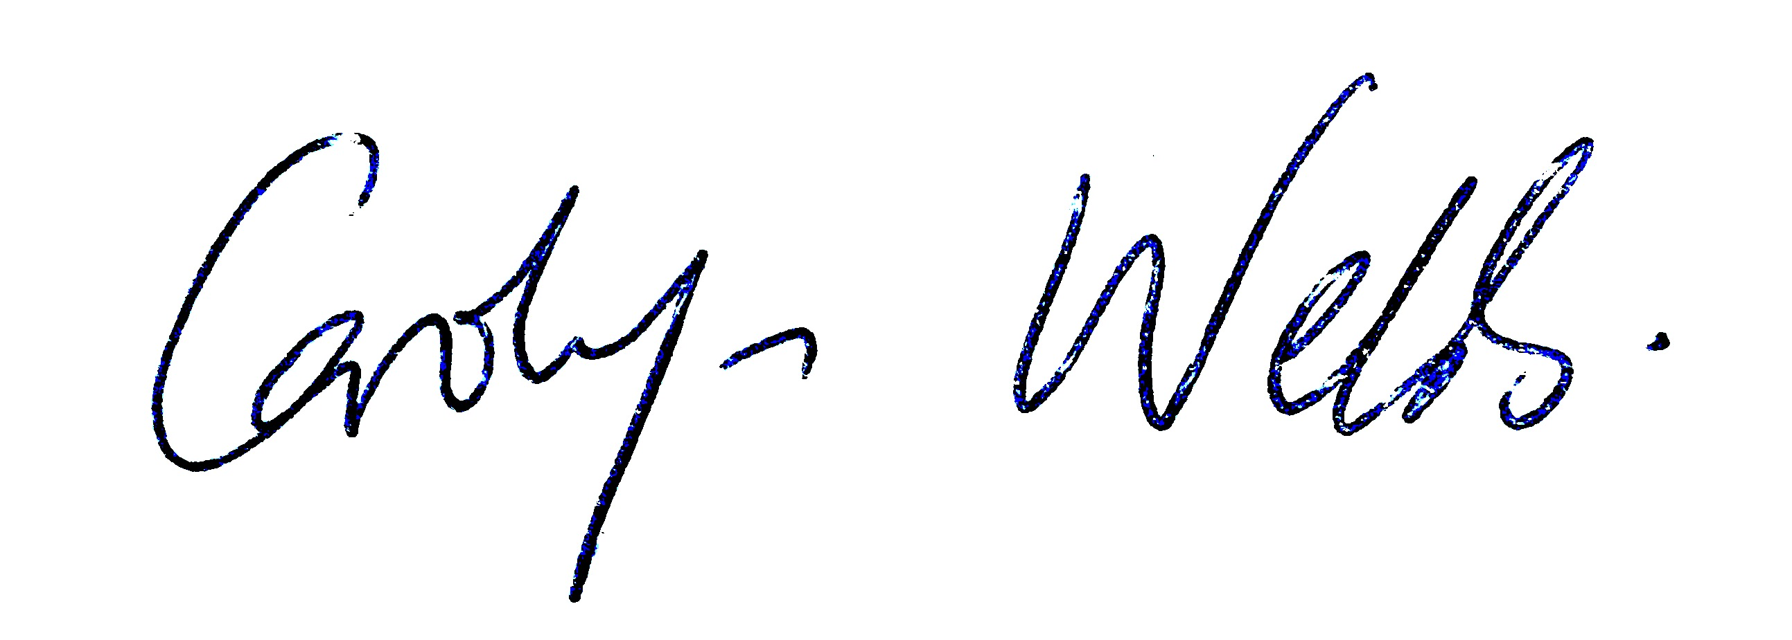

Carolyn Webb

Senior Speech and Language Therapist